Accelerating and Detecting the Particles of Physics!
a.k.a. How Do We Know There is a Higgs Boson?

Document Overview:
Standard Model Overview
Accelerating Particles
Using the ATLAS Detector to Investigate the Universe
Components of the ATLAS Detector
LHSee Android App

Minnesota Academic Standards in Science:
9.1.1.1.1 Explain the implications of the assumption that the rules of the universe are the same everywhere and these rules can be discovered by careful and systematic investigation.
9.1.3.4.1 Describe how technological problems and advances often create a demand for new scientific knowledge, improved mathematics and new technologies.
9.1.3.4.3 Select and use appropriate numeric, symbolic, pictorial, or graphical representation to communicate scientific ideas, procedures and experimental results.
9.3.3.2.1 Describe how the solar system formed from a nebular cloud of dust and gas 4.6 billion
years ago.
9P.2.2.1.1 Use vectors and free-body diagrams to describe force, position, velocity and acceleration of objects in two- dimensional space.

Connection to Nobel 2013 Speakers:
Dr. Tara Shears, Professor of Physics and Royal Society University Research Fellow at CERN, University of Liverpool, United Kingdom

Objectives:
- I can recognize the key particles in the Standard Model of Particles and Interactions.
- I can recognize characteristics of particle accelerators (Fermi, CERN, SLAC, etc) and that individual accelerators often have multiple types of detectors.
[sizes, energy, where located, etc]
- I can understand what physical quantities detectors are designed to measure.
[trajectory, energy, charge, momentum...]
- I can recognize detector signatures of typical particles.
[charged vs. uncharged, leptons (e, photons) vs. hadrons (p, n)], [LHSee Android app]

Type of Activity:
Reading, discussion questions, and web-linked videos.

Duration:
2 to 3 class periods

Description of Activity:
This document is a tutorial to develop an understanding of how particle detectors function, specifically the ATLAS detector on the LHC at CERN. It is setup to be completed in small groups of students or individually and will require an internet connection. Students will watch a series of short videos and collect information on particle accelerators and particle detectors.

The Standard Model
Particle physics is unusual! It is unlike much of what people think of as physics as it can be difficult to see the types of things being studied. The following video provides a short overview of what particle physics is. This was created just before the Higgs Boson was confirmed. Use this video as a tool to help organize your understanding of the particles of particle physics!

“CERN: The Standard Model Of Particle Physics”, 5:03, July 2010
http://www.youtube.com/watch?v=V0KjXsGRvoA

1. How is particle physics different from the common understanding that all matter is composed of protons, neutrons, and electrons?

2. Describe two examples of how the Standard Model has changed over time.

3. List the twelve basic building blocks that appear in the Standard Model:
QUARKS:
LEPTONS:

4. List the four types of forces as described in the Standard Model:

5. For each force type listed above, name the force mediating particle(s):

Dr. Tara Shears is a presenter at Nobel Conference 2013. She specializes in using the data from the Large Hadron Collider to identify particles that result from collisions. She explains, in the first few minutes of this talk, the importance of the fundamental particles to our understanding of both the tiniest bits of matter as well as the behavior of the largest objects in our universe and beyond.

Dr. Tara Shears - TEDxManchester – “The God in Small Things”
http://www.youtube.com/watch?v=DOIs5p-Jg3U

In the first 4.5 minutes of this talk, Dr. Shears lays out the Standard Model as the foundation of all things we know. Please watch this overview, but save the rest of the video for a bit.

Note that the focus of this section is the idea the Standard Model is an organizing principle for all things. Now use Dr. Shear’s talk to verify the information that you have collected in the tables above.

Accelerating Particles
Much of what physicists have been able to learn about particle physics has been accomplished through the use of tools called particle accelerators. Much like the name implies, particle accelerators do just that...they are devices to change the velocity of particular types of particles and cause collisions between various particles to investigate the makeup of these particles.
This short article from the Center for European Research Nuclear, CERN, provides an overview of what particle accelerators are and the basic principles about how particle accelerators work.
http://home.web.cern.ch/about/how-accelerator-works

Much like a microscope allows a person to view light from a tiny object, a particle accelerator allows physicists to gather information about the makeup of fundamental particles. Each accelerator has particular characteristics that allow it to perform its intended task.

Now research basic characteristics of several particle accelerators currently in operation on Earth. Be sure to choose at least four different detectors. The table below may help to organize the information.
Use this reference to choose accelerators to study: http://www-elsa.physik.uni-bonn.de/accelerator_list.html.

Accelerator Name | Location | Circumference or Length  (if ring or linear) | Detectors | Energy Range Studied

6. What are the key research focuses of each of these accelerator facilities?

7. What ‘big picture’ questions are physicists at accelerator labs working to answer?

There are four different detectors on the Large Hadron Collider at CERN. What does each detector accomplish?
http://home.web.cern.ch/about/accelerators/large-hadron-collider

Detector | Purpose

Using the ATLAS Detector to Investigate the Universe
Now that there is a basic understanding of the types of detectors in the ATLAS facility at CERN, lets turn to the questions of nature that become investigable with these complex tools! Particle accelerators have given humans a unique lens with which to develop an understanding of both the smallest and largest parts of our universe. While light microscopes help us probe things in the order of millimeters with visible light waves, in order to see things on the scale of atoms, humans have developed ways to probe with electrons in a tool called an electron microscope. Yet the particles that make up atoms have been further broken apart by particle physicists. The detectors illustrated here are needed to observe these even smaller particles being studied now at FermiLab, CERN, and other facilities.

It is through the development of these detectors that humans are able to delve further into the big questions of how our universe came about and what the fundamental building blocks of the universe might look like. The teaming together of scientists and engineers is completely necessary to be able to explore these questions.

Return to Dr. Tara Shears talk (starting about 4.5 minutes in) and listen to her describe the way that the Large Hadron Collider has enabled teams of physicists to seek answers to the question of the origins of the mass of particles.

Dr. Tara Shears - TEDxManchester - The God in Small Things
http://www.youtube.com/watch?v=DOIs5p-Jg3U

8. What is so critical to physicists about needing to identify that the Higgs Boson exists?

9. Why has the search for the Higgs Boson shifted between different particle accelerators?

10. Dr. Shears states the approximate number of total collisions have taken place as of the date of this talk. She also indicates that about how many collisions occur each second in the LHC. Use this data to calculate the total operating time of the LHC thus far. While the result will likely be in seconds, convert this to a unit of time that is most logical to understand.

11. What feature in the data shared by Dr. Shears [at this time] indicates that there most likely IS a Higgs particle?

12. Why was further work still needed by the team at the LHC to conclusively show the Higgs exists as of the time of this talk?

13. When asked IF we understand the universe, Dr. Shears responds “Maybe” during this talk based on the uncertain confirmation of the Higgs Boson. Since the recording of this talk by Dr. Shears, how has physicists’ understanding of the Higgs come to a place where we can say we DO further understand the universe?

Components of the ATLAS Detector
The collisions in the LHC happen at these four detectors labeled in yellow. However, there are several other components that are necessary to bring the protons or other particles into the ring. Notice in this diagram the locations of the four detectors as well as the other components of the system.
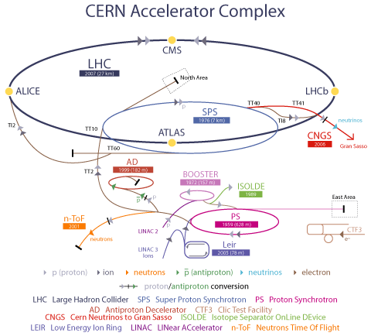
Image from: http://hepoutreach.syr.edu/Index/accelerator_science/accel_overview.html

Much of the work to identify the Higgs Boson has happened in the detector called the ATLAS, which is an acronym for “A Toroidal LHC ApparatuS”. A typical detector can identify three properties of particles. The first is the particles trajectory, or the velocity with which it is moving. The second is the electric charge and momentum of the particle. And the third is the amount of energy the particle has. Finally there is a muon detector for the most energetic particles produced in the collision.

First, the trajectory is measured closest to the collision. Next, the charge and momentum are identified by examining the shape of the projectile’s path as it interacts with magnetism. Next, the energy of the particles is determined by a calorimeter. And finally there is a muon detector for the most energetic and massive of particles that make it that far.

Trajectory Measurement
Measuring the speed of something is a simple process. Measure the time it takes for an object (for instance, a baseball) to move from one point to another, and then divide the distance it travelled by how long it took (the baseball went 40 meters/second). To find the velocity of an object, simply add the direction the object went in addition to its speed (40 meters/second to the north).
Scientists at CERN use a similar process to measure the velocity of particles moving through the LHC. They set up multiple gates (imagine window screens facing each other in a row) that the particles pass through as they go along the LHC and calculate the speed using the same method as we would. To find the direction, the scientists look for the "holes" formed from the particles passing through the screens. Comparing the holes gives the path and direction of the particle. This is the particle's trajectory.

Charge and Momentum Measurement
To determine the charge of a particle, we can use its interaction with magnetism. The ATLAS detector is surrounded by very large electromagnets that establish a magnetic field in the area where the collisions take place. The benefit of the magnetic field is that it will cause any particle with an electric charge to curve in its path.

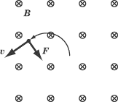 | This diagram shows an example of how this happens for an electron with a negative charge. The circled Xs represent a magnetic field pointing out of this page and the velocity arrow indicates the direction of the trajectory of a charged particle. This particle is forced to its left by the magnetic force on it. If this were a positively charged particle, it would be forced to the right instead and thus curve the other way.

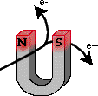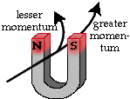 | So by looking at the curve (or not) of the particles path within the detector we can tell whether they are charged and how much they are charged. We can also tell how much momentum they have. Particles with more momentum will be curve less and particles with less momentum will curve more for the same magnetic field strength.  Image from The Particle Adventure

Energy Measurement
To determine the amount of energy each particle has, the detector uses calorimeters to capture the particles. As the products of the collision stream out from the location of the collision, they travel into material that is increasingly more difficult to penetrate. These materials, called calorimeters, allow the experimenters to determine the energy of each individual particle by measuring how far into the calorimeter the particle travels before losing all of its energy. There are two different layers of calorimeters in the ATLAS detector, one for LEPTONS like electrons and photons and a second for HADRONS like protons and neutrons.

Muon Detectors
Beyond these three components is a layer of magnetized iron. Any particles that make it beyond the calorimeters and into or through the iron layers are muons. Muons are much like electrons but have about 200 times the mass. This final layer is designed to identify muons.

All of these pieces of information are available for each particle produced in collisions. The collision and all data collected from it are called an "event." By analyzing the data from events and using the above information, you can identify what particles were formed in the collision, and maybe even find a Higgs boson!

Here is a conceptual cross sectional view of what the ATLAS looks like:

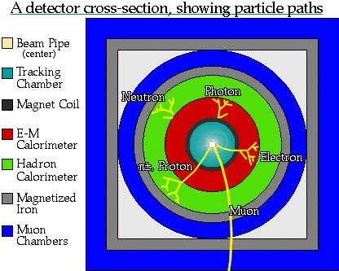
Image from The Particle Adventure

And here is a schematic showing how these pieces fit together into the ATLAS detector at CERN. Notice the size of the people along the bottom of this image that have been added for scale.
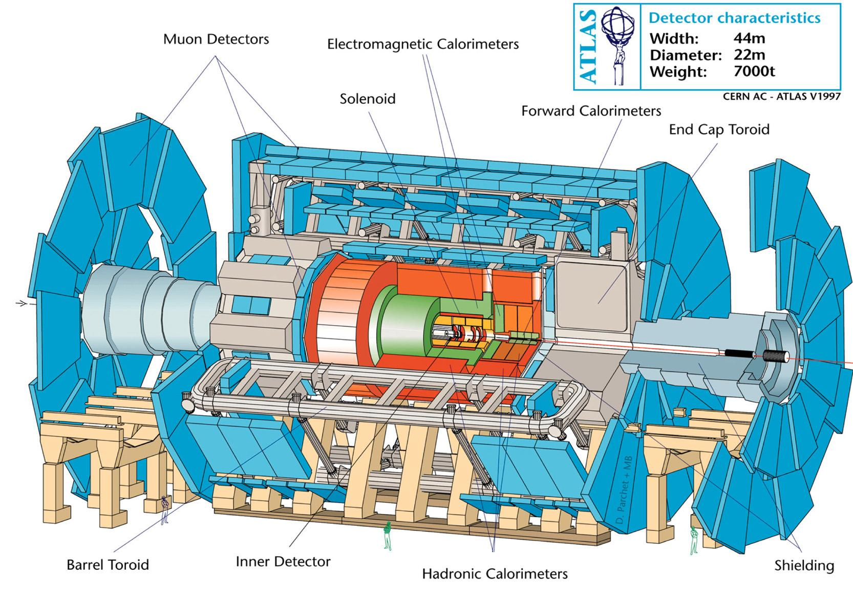

Many, many, images of the ATLAS detector are available from CERN at http://www.atlas.ch/photos/index.html.
For some good practice, try this particle identification quiz from “The Particle Adventure”. http://www.particleadventure.org/quiz_track.html

LHSee Android App

An Andriod app has been produced an excellent tool that provides both a tutorial about the ATLAS detectors operation and provides a glimpse into real-time data from the detector. This is available as an app on the Android platform and is worth some exploration. The menu of the app is below. Within the ‘Hunt for the Higgs Boson’ section, users can look at real data from the ATLAS and practice identifying the type of particles produced.

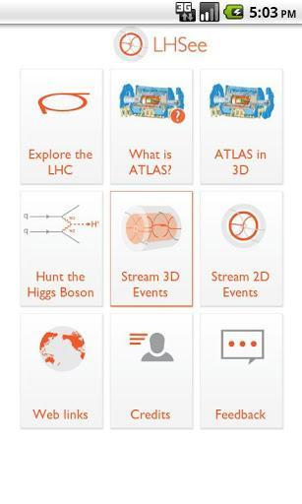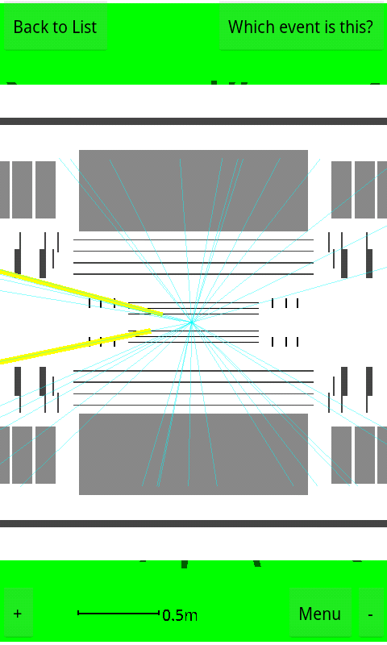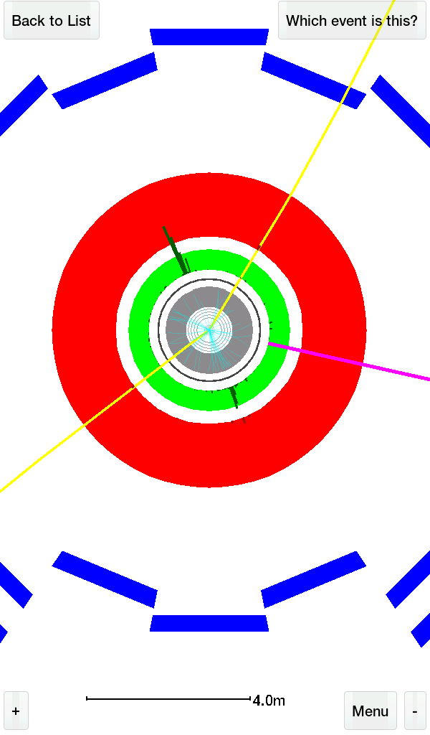

Further information on the development of this app is here:
http://blogs.it.ox.ac.uk/ltg-casestudies/2012/08/22/student-innovation-the-lhsee-app/

Within the list of events to identify in the game, one shows the creation of the Higgs boson. To add a competitive side to the game, split into groups and compete to see who can find the Higgs first!

Additional Resources

The website “The Particle Adventure” http://www.particleadventure.org/ is loaded with great resources and instructional tutorials.

CERN Land - http://www.cernland.net/

There are other ways to detect particles without multi-million dollar, five-story tall machines. In fact, you can build your own particle detector with dry ice and a few other materials. Follow the instructions in this video to build a cloud chamber if you do not already have one.
http://www.youtube.com/watch?v=400xfGmSlqQ

Using magnets, you can see if the particles detected are charged depending on their curve (or lack of), the same as ATLAS does.

A typical image of Standard Model particles from FermiLab.
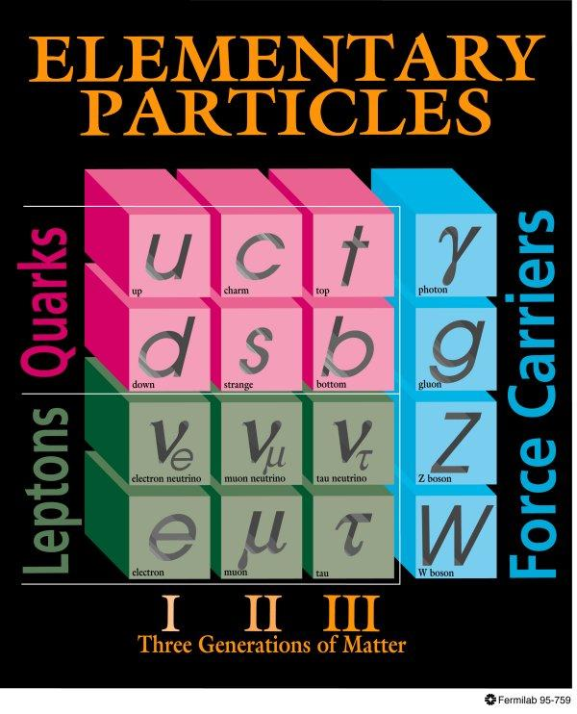
http://www.fnal.gov/pub/inquiring/matter/madeof/

